Lab 3
- Write a Java program to find the largest of three numbers.
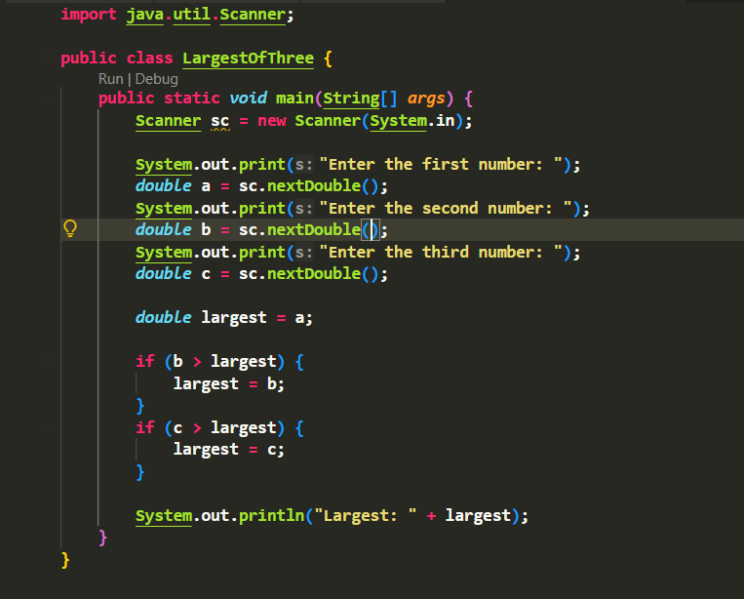

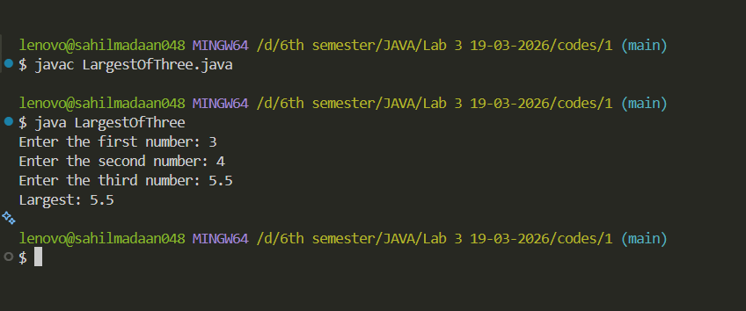

OUTPUT:

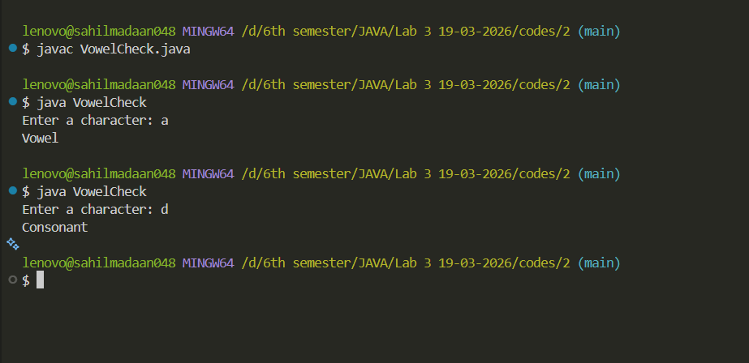

Lab 3
- Write a Java program to check whether a character is a vowel or consonant.

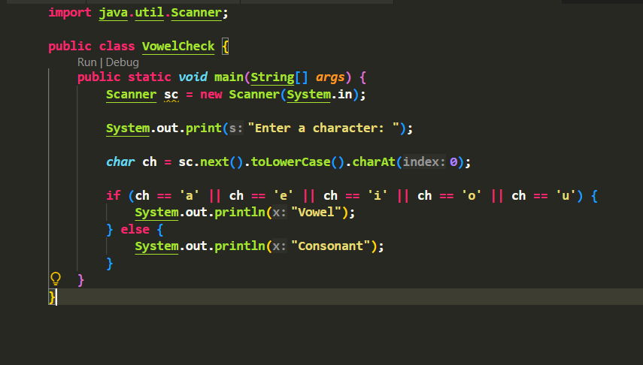

OUTPUT:

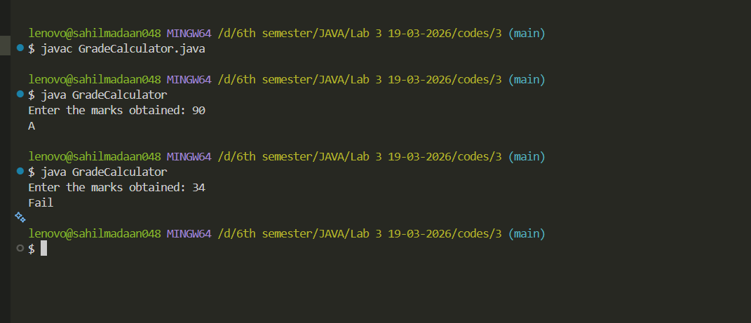

Lab 3
- Write a Java program to calculate grade based on marks:

• 90+ → A
• 75–89 → B
• 50–74 → C
• Below 50 → Fail
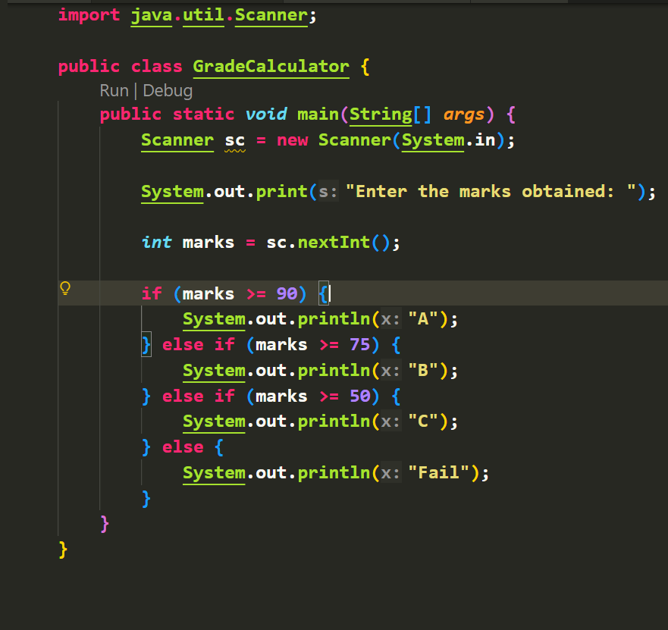

OUTPUT:

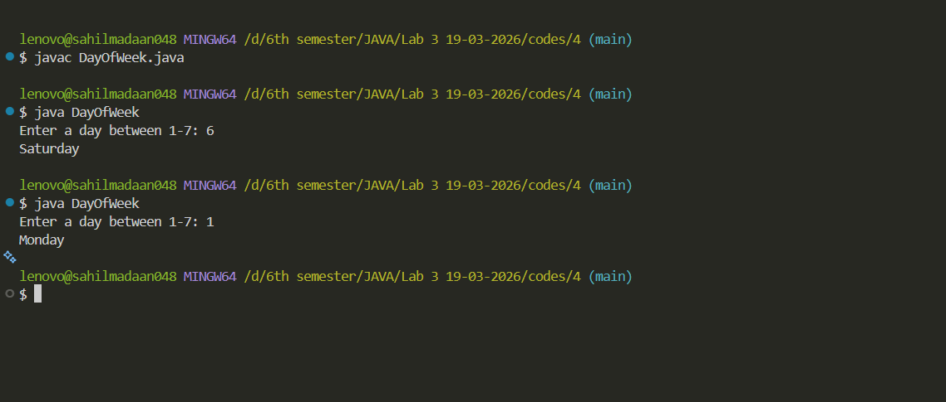

Lab 3
- Write a Java program using switch to print day of the week based on number (1–7).

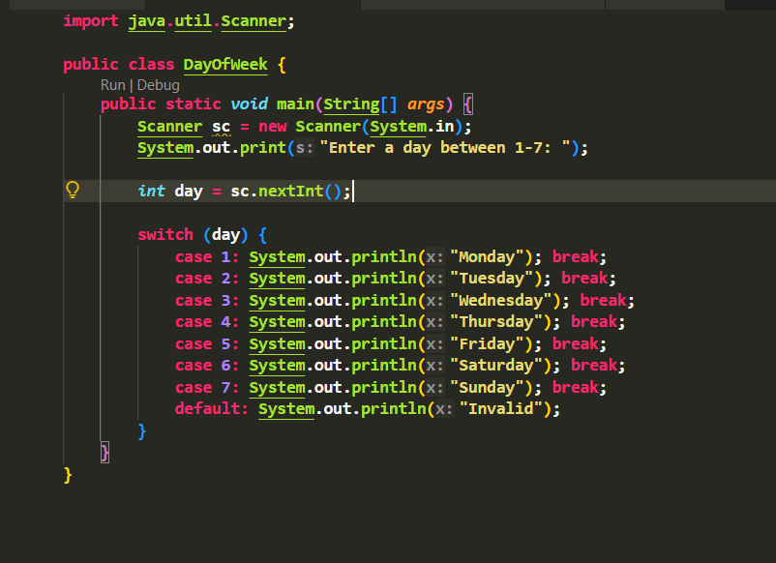

OUTPUT:
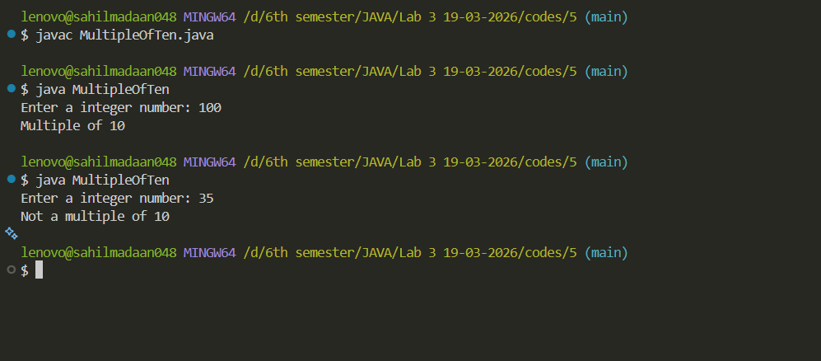

Lab 3
- Write a Java program to check whether a number is a multiple of 10 or not.

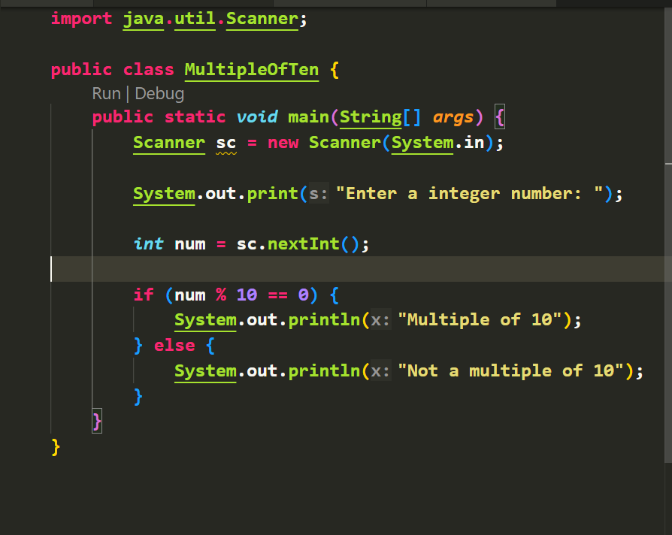

OUTPUT:
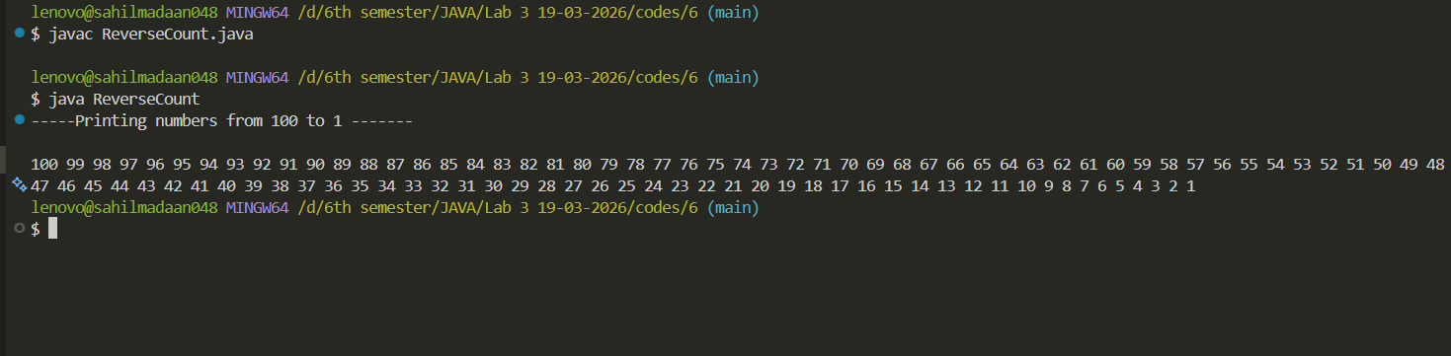

Lab 3
- Write a Java program to print numbers from 100 to 1 using a while loop.

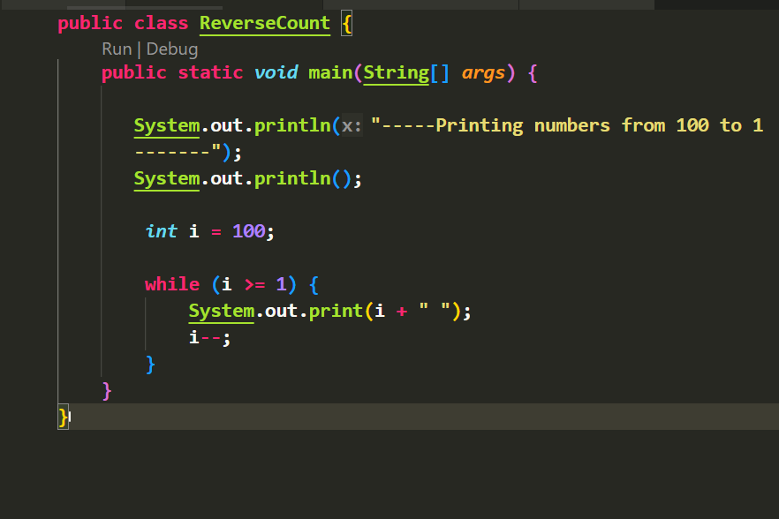

OUTPUT:
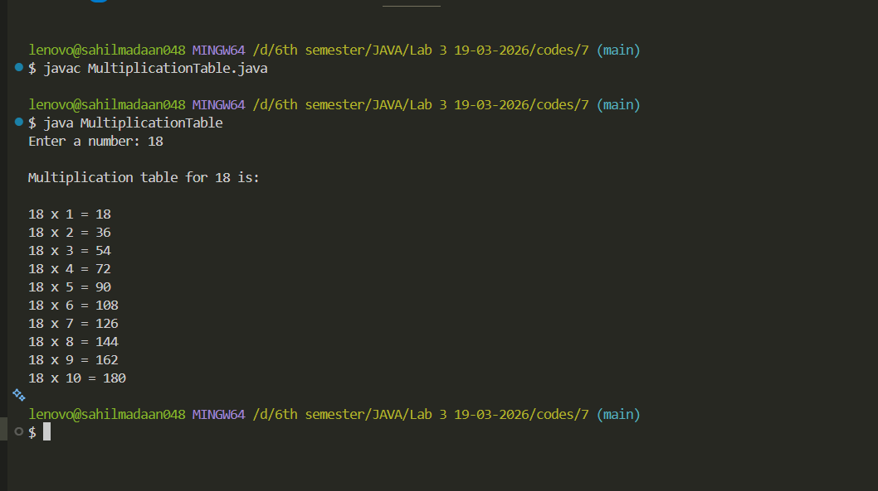

Lab 3
- Write a Java program to print the multiplication table of a given number.

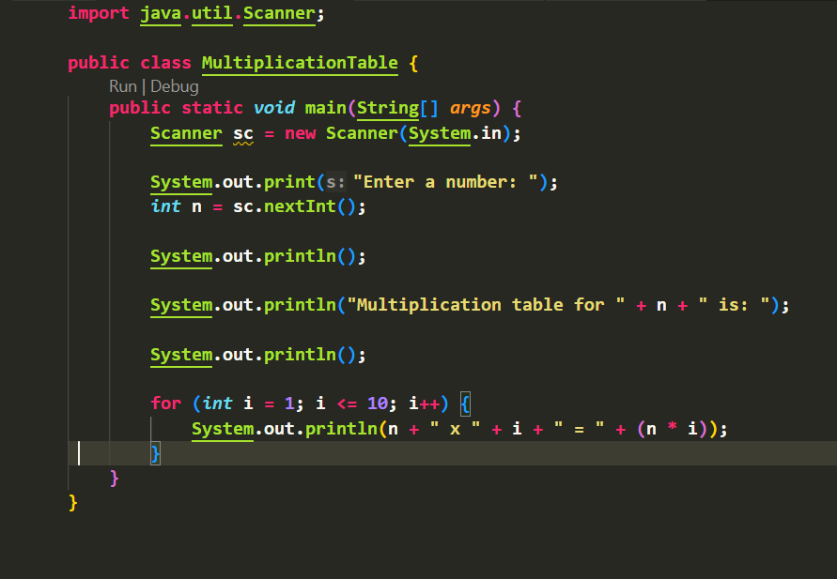

OUTPUT:
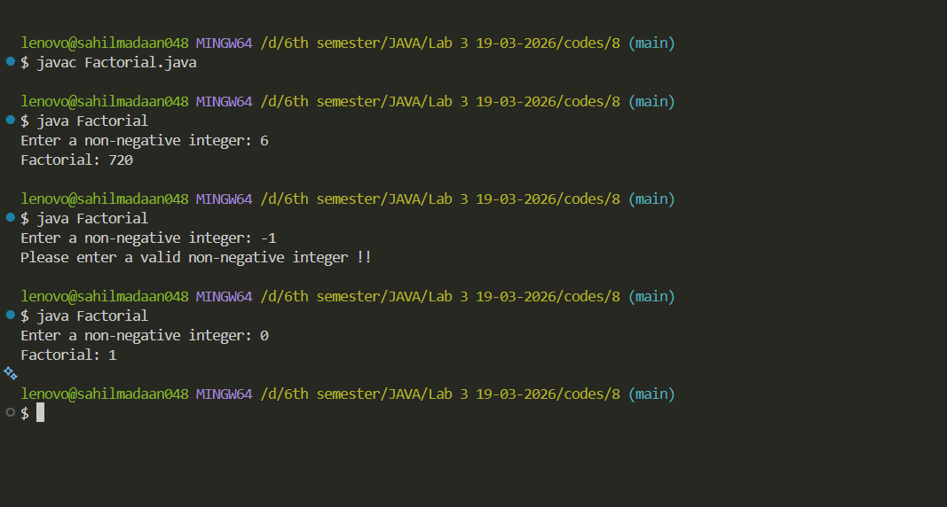

Lab 3
- Write a Java program to calculate factorial of a number.

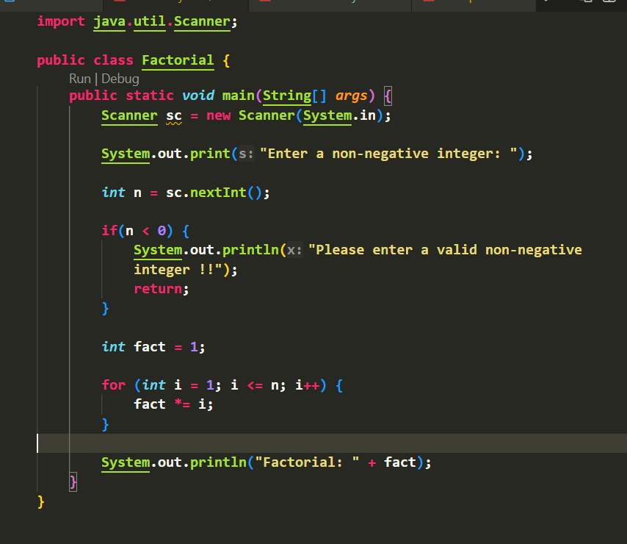

OUTPUT:

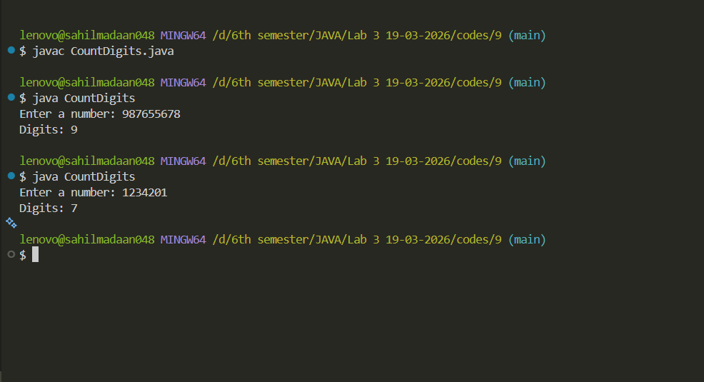

Lab 3
- Write a Java program to count number of digits in a number.

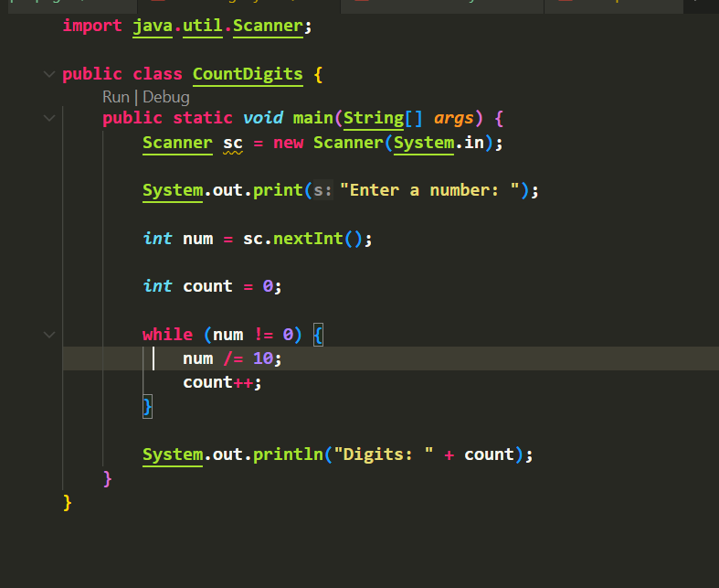

OUTPUT:
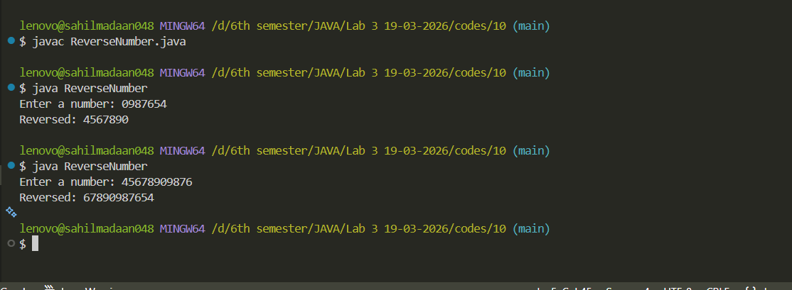

Lab 3
- .Write a Java program to reverse a number.

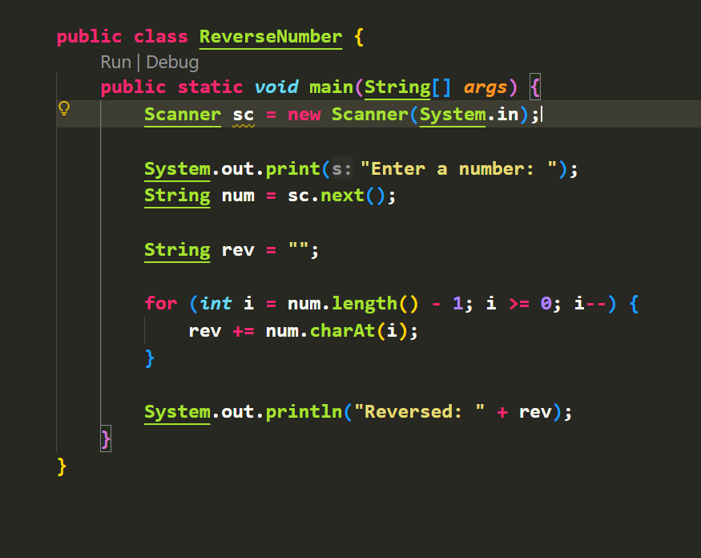

OUTPUT:
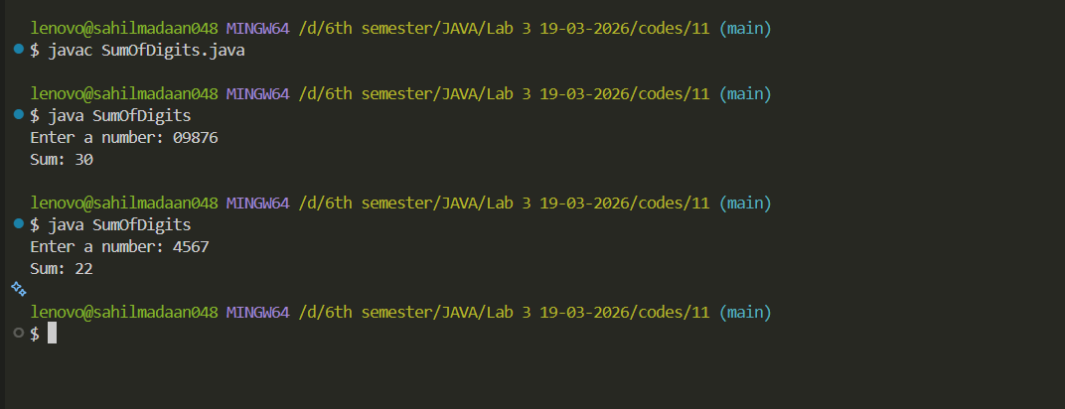

Lab 3
- Write a Java program to find sum of digits of a number.

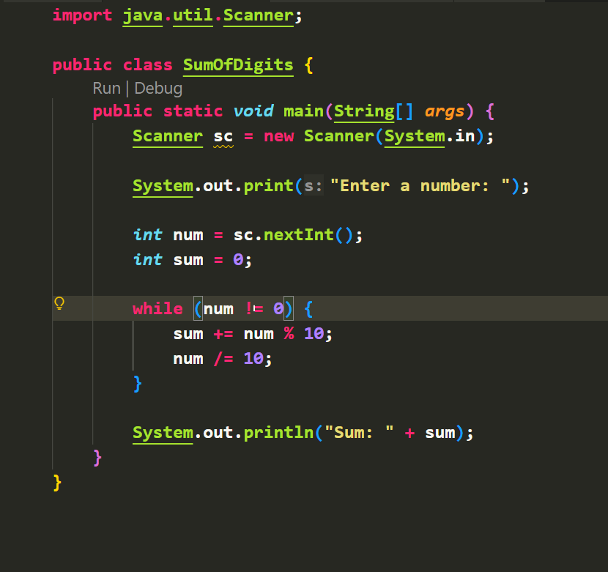

OUTPUT:
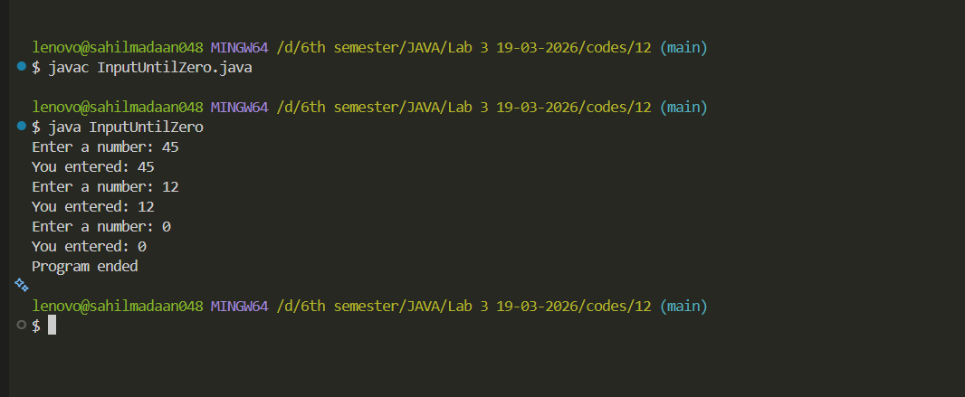

Lab 3
- Write a Java program to keep taking input until user enters 0.

